Phase 0—Introductory: Presentation of Q0 and first exploration of the locks

Main objectives and issues
For the teacher
- Presentation of the generative question Q0, along with the first collection of padlocks that must be distributed among the different groups.
- To bring out the need to establish a common terminology to refer to the different variables that characterize each padlock. Not to do so until after the pooling of questions Q0[1].
For students
- First exploration of Q0 and formulation of questions related to the need to calculate how many codes a padlock supports.
- Propose terminology to refer to the different elements and variables of the padlock (cell , number, code, etc.) and see the need to establish a common terminology.
- Develop verbal, communicative and analytical skills to formulate, discuss, write and present different questions and answers in small and large groups.

Phase structure: main moments, timing and classroom dynamics

[1] Presentation of Q0 and collection of derived questions 20-30 min
The teacher presents the first collection of padlocks [ Padlocks ] and introduces the generative question Q0 about: Of the collection of padlocks, which padlock is the most secure? [ Guided presentation ].
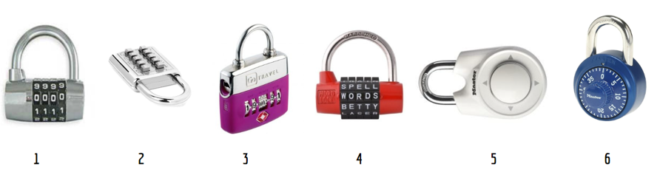
The teacher collects a first shower of questions derived from Q0 and is responsible for outlining the opening of the question and answer map, on the board and later digitally (see example in Image 1A and Image 1B ). The discussion cannot be directed solely at the technology of the padlock or the material with which it is manufactured (at no time will the padlock be opened by breaking it or forcing it). Table 1 (found below and as a separate document for teachers) includes a description of the characteristics of each padlock, in addition to being able to physically show them.
Q1 should emerge : How many codes does each padlock accept? Or , under the hypothesis that they know nothing more about padlocks apart from their characteristics, Q1.1 is raised : Which of the padlocks accepts the most codes?
[2] Sharing common terminology 15 minutes
At the end of the previous moment, it is very likely that individual students will use different terminology. to refer to the elements or variables that characterize each of the padlocks.
It is therefore necessary for the teacher to share and agree on a common vocabulary that will be necessary so that each group can start working with the padlocks to discover the number of codes they support. See Image 2 , transparency included in the Guide Presentation .
[3] Formation of groups for the study of Q1 and distribution of padlocks
Based on this sharing, the teacher specifies Q1 and divides the students into groups of 4-5 members . Each group receives a different padlock or, if there are more groups than padlocks, the assignment to one of the padlocks is doubled.
The teacher can also begin to present (and if there is time) the Report-presentation 1 that, by working groups, must be prepared, as a summary of the study on the padlock for which they are responsible.

Resources and materials needed/available
For teachers
guide presentation . The guide presentation covers the entire experiment, from Phase 0-Introduction to Phase 4 .
Preparation of the first draft of the question and answer map on the board, to then be transferred to, for example, a Padlet or a MIRO or a Canvas ( see Image 1B ) with access to all students in the same class.
For students
Physical padlocks , 6 in total , plus a description of the characteristics of each padlock, oral and included in the Guide Presentation. A different padlock is given to each group.
Report -Presentation 1 ( see Phase 1 material ) is a group report that the teacher can begin presenting at time [2] or in the following phase: Phase 1 ( see structure discussed in the next guide).

Relevant comments for Phase management
There are padlocks that are more difficult than others. See Table 1 (found below and as a separate document for teachers ) with the described characteristics of each padlock.
The teacher must keep this in mind when distributing them among the working groups.
Resisting...
Avoid providing information about the different ways, strategies or techniques to address Q0 or making specific and guided proposals on how to count the number of padlock codes.

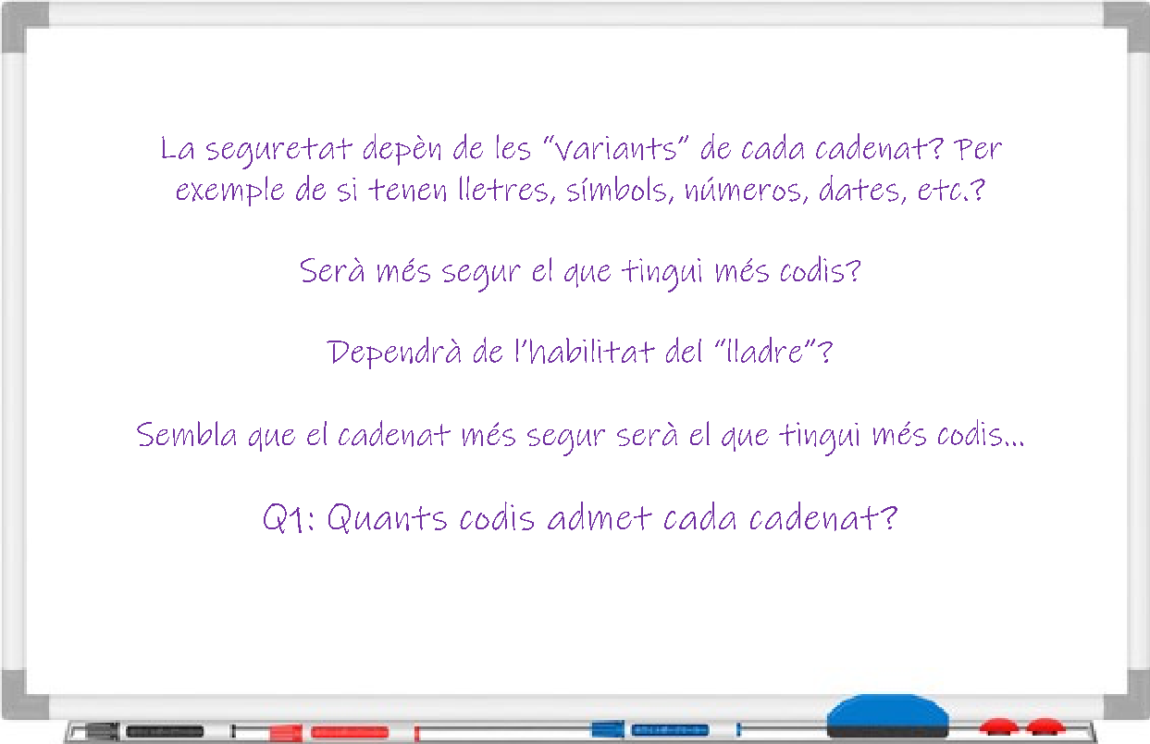

Image 1A. Example collection of questions or issues from Phase 0, moment [1]

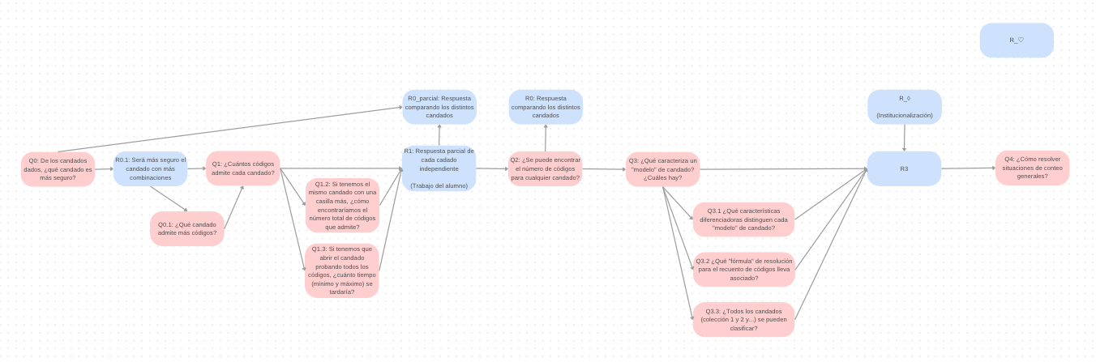

Image 1B. Example of a digital question and answer map ( Canva )

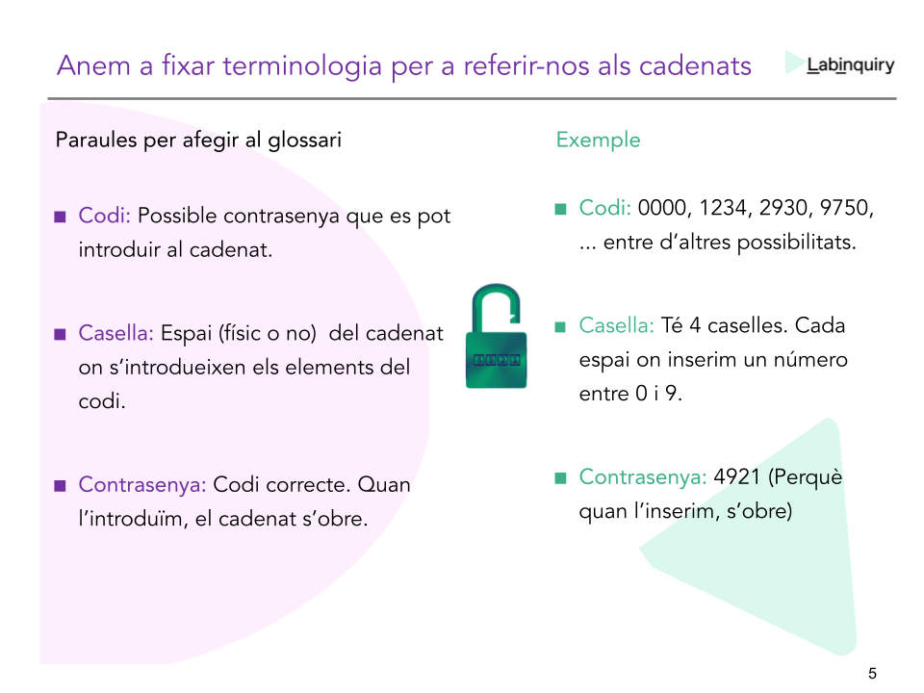
Image 2. Proposal for common terminology on the elements or variables of padlocks

